# A logo with a circle and a circle with a chain and a circle with a circle and a circle with a circle with a circle and a circle with a circle with a circle with a circle with Description automatically generated7th Assignment spl report About :cantor pairing functions using Go lang

# Supervised by TA : Mahmoud ElMorshedy

Name: Abdelrahman Adel

Reg Id: 211002797

Cantor Pairing Function Program

importing libraries we will use like errors for handling errors and fmt for input and output

and strconv for parsing

and time for time delay in loading animation

cantor_pair is function to encode two numbers in one number and it takes two arguments and should take two positive numbers then if condition to check positive or negative number if negative will give error

then do encoding operation like equation in the figure below

The inverse of Cantor Pairing function

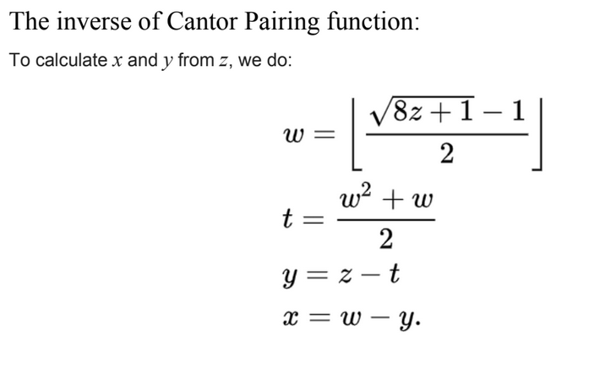The inverse cantor pairing functions take one argument z which is encoded number so we will check if z is positive or not if not will print 0 and 0 and gives you error input must be a positive integer Then calculate w and t and y and x then like the fig below

input function to obligate the user to put positive numbers

and loading function is for animation to display characters in delay time which make program more cool

main function has a selecting menu to select functions like 1cantor pairing and 2inverse cantor and 3 exit

# A screenshot of a computer Description automatically generatedRunning program

The output is correct in cantor pairing and inverse pairingLike these figures

Thank

You

😊